INSTALLATION GUIDE
System Name
AR Scanner
Installation Steps
1. Unzip Files
- Extract all files into a folder of your choice.
2. Folder Structure
- Open the folder after extraction.
- Ensure the directory structure matches the example below: 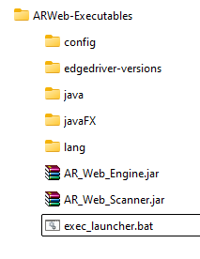
Example:
- Create the necessary Database and Logs/Reports folder structure as shown:
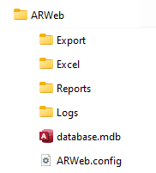

3. Modify Configuration
- Edit the file exec_launcher.bat to update the folder path according to your setup.
- Update the SET PATH variable in exec_launcher.bat as needed. For example:
Default:
SET PATH=C:\Program Files\ARWeb;C:\Program Files\ARWeb\java\bin;C:\Program Files\ARWeb\javaFX;C:\Program Files\ARWeb\javaFX\lib;%PATH%
Custom Example:
SET PATH=D:\Projects\AllinWeb\ARWeb-Executables;D:\Projects\AllinWeb\ARWeb-Executables\java\bin;D:\Projects\AllinWeb\ARWeb-Executables\javaFX;D:\Projects\AllinWeb\ARWeb-Executables\javaFX\lib;%PATH%
- Also, ensure the correct path is set for ARWeb.config. If you have placed it in a different folder, update the reference accordingly:
- "D:\Projects\AllinWeb\ARWeb\ARWeb.config"
Notes
- Ensure all paths are correctly set in exec_launcher.bat before running the system.
- Verify that the required folder structure exists before execution.

End of Installation Guide

